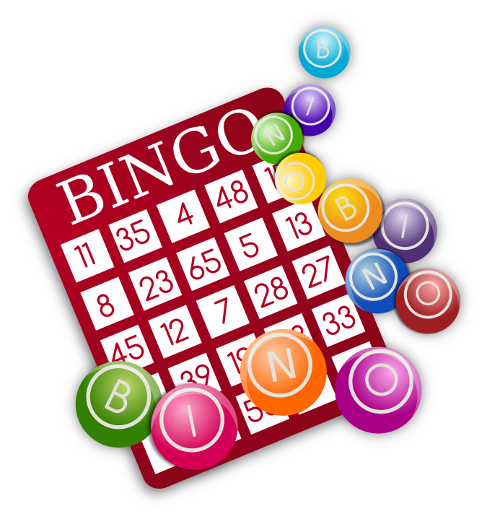
CONDITIONING BINGO

To Prepare & Play:
- Edit the conditioning exercises as you see fit! Currently it's set up so that each letter column focuses on something different (arms, legs, core, cardio & active flexibility).
- Edit the # of reps. Currently there are two numbers - one above and one below the exercise listed. Depending on the group, you can choose more reps (number below) or less reps (number above). This allows you to use the same card for multiple groups.
- Print!
- Consider laminating multiple copies. Use a dry-erase marker to check off the completed exercises, then erase when done! Alternatively place in a plastic paper sleeve.
- To play, give the athletes a challenge (i.e. make a horizontal line, X, four corners, chevron, full card, etc) -- when they complete an exercise they check it off. Once they complete the challenge, they get "Bingo!"

CONDITIONING
B | I | N | G | O
3  Chin Ups  5 | 10  Lunges  (both sides)  15 | 30 sec  Hollow body rocks  60 sec | 4 lengths  Sprints  8 lengths | 10  Forward leg kicks (both legs)  15
10  P-Bar dips  15 | 10  One-leg stand ups (from block)  15 | 30 sec  Side rocks  (both sides)  45 sec | 40  Jumping Jacks  80 | 10  Side leg kicks (both legs)  15
10  Tri-cep dips  20 | 60 sec  Wall Sit  90 sec | COACH'S  CHOICE | 2 x 10  Consecutive tuck jumps  4 x 10 | 10  Back leg kicks (both legs)  15
10  Push Ups  15 | 20  Heel raises  30 | 10  V-Snaps  (or tuck ups)  15 | 45 sec  Mat jumps  90 sec | 2 x 15 sec  Bridge  3 x 15 sec
10 sec  Chin hold  20 sec | 20  Squats  30 | 10  Sit Ups  20 | 45 sec  Mat jogging  90 sec | 2 lengths  Pike walks  4 lengths

